USER REQUIREMENTS

The Bidder should provide the following in the specified order in Section 4 of the proposal/bid document.

Provide detail information of the proposed solution as per document enclosed. Please note that marking should be carried out in the following manner; The Remarks column should be used to explain or provide detail information.

DESCRIPTION | REMARKS
Rating - 5 | If the User requirement is met 100% as defined in the RFP without any work around method.
Rating - 4 | If the User requirement is met 75% as defined in the RFP without any work around method. Define the number of hours required for the modification and cost in US$ in the Remarks column, in order to provide 100% functionality as defined.
Rating - 3 | If the User requirement is met 50% as defined in the RFP without any work around method. Define the number of hours required for the modification and cost in US$ in the Remarks column, in order to provide 100% functionality as defined.
Rating - 2 | If the User requirement is met 25% as defined in the RFP without any work around method. Define the number of hours required for the modification and cost in US$ in the Remarks column, in order to provide 100% functionality as defined.
Rating - 1 | If the User requirement is met as a Work around method defined in the RFP. Define the number of hours required for the modification and cost in US$ in the Remarks column, in order to provide 100% functionality as defined.
Rating - 0 | If the User requirement is not met as a defined in the RFP and modifications are required. Define the number of hours required for the modification and costs in US$ in the Remarks column.

The NBL rating is as follows:
1 = critical; 2 = essential; 3 = nice to have

CUSTOMER INFORMATION/ACCOUNT OPENING

Ref : | User requirements | NBL Priority | Bidder’s Rating | Bidder’s Remarks
 | Facility to maintain a customer database with the following details.  Name with initials, surname and short name  Title Mr./Ms/Mrs./Rev/Dr/Master  Address  Telephone (Office, Home), mobile and fax number  Email address  National Id. Number and Passport number (either one of them should be mandatory)  Income tax file number (for individuals)  Business registration number  PVS number (Given by Registrar of Companies)  Business Turnover Tax file number (for corporate/business)  Main City (Mandatory) which is part of the address  Date of Birth  Diary attached to the CIS to record discussions etc., for others to follow up  Priority status/tag  Relationship Manager Code  Tags for; ATM, Internet and Phone Banking, Credit Card, safe Deposit Locker etc.,  Industry Code  Province/District/Country | 1 | 5 | Supported by T24.  Local fields can be added using the Local Reference tool to identify whether the customer has been availing other services (ATM Card, Internet Banking, SMS Banking, etc).  T24 allows relation codes to be defined by the user. The relation codes can then be used to link a customer with another customer or an account with another account.  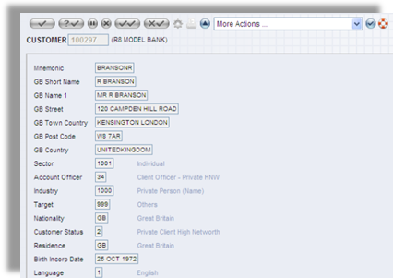  Figure 1. Customer Information
 | Facility to classify an account for various analysis purposes as and when need arise. i.e. Industry, province, post code, etc. (by way of user definable additional free fields) | 1 | 5 | Local fields can be added using the Local Reference tool to identify whether the customer has been availing other services
 | Facility to designate accounts as “E-accounts” where withdrawals at teller counters would automatically trigger a charge. | 1 | 5 | Each account will be assigned a unique account ID. The account ID can be auto generated and the pre-defined format required can be applied using a local API routine.
 | Facility to maintain the existing customer number and account number with the provision to add the bank’s branch number at the beginning for identity. The present system generated number consists of three leading numeric for the branch code and 16 digits for the account/customer number. (7 used with leading zeros) | 1 | 5 | Each customer/account will be assigned a unique customer ID/account ID. The customer ID/account ID can be auto generated and the pre-defined format required can be applied using a local API routine.
 | The proposed software should identify a Customer of the bank with one customer number with a facility to identify the branch which customer belongs to (may be a leading prefix indicating the branch code) | 1 | 5 | Each customer will be assigned a unique customer ID. The customer ID can be auto generated and the pre-defined format required can be applied using a local API routine.
 | Accounts under a Customer number should be differentiated by the branch where he holds his account and a prefix to identify the type of account. | 1 | 5 | Every account has information of branch code, including head office code.  Product type/account type is mandatory for account attributes  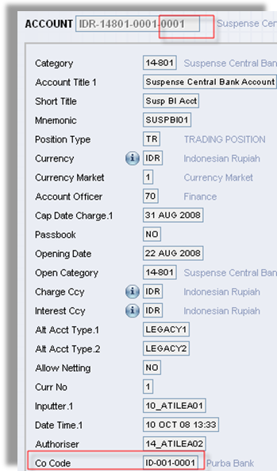  Figure 2. GL code contains Head office information which is sub division code that is defined above
 | The account numbering system should support auto generation of account numbers as well as customer requested account numbers (with check digit). | 1 | 5 | Each account will be assigned a unique account ID. The account ID can be auto generated and the pre-defined format required can be applied using a local API routine.
 | Facility to link Group companies with associates and subsidiary companies accounts within the bank/branches. | 1 | 5 | Supported by T24  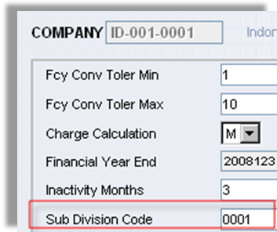  Figure 3. Sub division code can be defined for each branch/company
 | Facility to mark the account with a movement codes  Eg. VIP, Never refuse payment, Call Privilege Banking if overdrawn, Restricted account regulations, account blocked/pledged etc., | 1 | 5 | Supported by T24. Handled by Posting restriction feature.
 | Ability to assign special authority indicators to the above account movement code  Eg: For reference only, Postings to accounts attached to the Account movement status code will create a warning to input staff, will be rejected and an authorizer can authorize, will be rejected and an authorizer cannot authorize etc., | 1 | 5 | Supported by T24. Handled by Posting restriction feature.
 | Transactions to an account to be grouped to a Transaction Type and define whether these types could affect the account status  Eg. Affect dormant status, affect stagnant indications and affect unclaimed indication. | 1 | 5 | Handled by Transaction definition feature.
 | Facility to scan and store signature/s, operating instructions by account number wise/customer wise. | 1 | 5 | Images of photo and/or signature are captured, stored using the Image Management module and link to the Account record.
 | Facility to record and store documents that should be in the mandate file. Eg: operating instructions and signatures Deleted customer’s data to be available in history file which could be accessed either online/off-line. | 1 | 5 | Supported by T24.  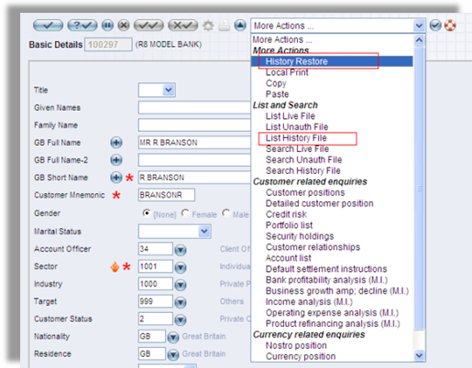  Figure 4. More Actions
 | Facility to tick off over defined mandate document requirements (per product type), with the facility to generate reports on missing documents and reminder letters automatically. | 2 | 5 | Handled by T24 Document Management system.
 | Provide for central input of interest rates and charges for different maturities, for different currencies with an ability to vary at account level. | 1 | 5 | A “Credit Maximum Rate” can be input to define the capped rate (or maximum rate) for credit interest to be applied to the CR balance type. If the rate that is derived by T24, after applying any spread, is more than this rate then the interest rate will be capped at this value.  Similarly a “Debit Minimum Rate” can be input to define the floor rate (or minimum rate) for debit interest to be applied to the DR balance type. If the rate that is derived by T24, after applying any spread, is less than this rate then the interest rate will be set to this value.
 | Use centrally input exchange rates for inter account transfers, payments etc., with an ability to change at transaction level. | 1 | 5 | Any transactions that are involving exchange rate, system will use bank wide parameter.  T24 has feature to defined which currency table that is going to be used for any T24 applications and transactions  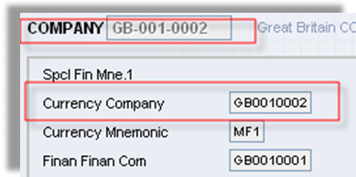  Figure 5. Company setting
 | Facility to make amendments to the customer data base with an option of Mass Data change Eg: Changing of Customer/Account information across all records in the Master file with ability to select any data record in the file. (change of Relationship manager code from XX to YY, for all records where RM code =XX) These changes are required to be authorized and system should generate a number of records selected for change as an indication to the authorizer. | 1 | 5 | Supported by T24 Security Management System.
 | Controls
 | Facility to ensure that changes made to customer database remain inactive until authorized. | 1 | 5 | Supported by T24 Security Management System.
 | Facility to record the identity of staff that carried out changes/authorization to the customer database. | 1 | 5 | Supported by T24 Security Management System.
 | Facility to view details even after the account is closed. | 1 | 5 | Supported by T24
 | Reports
 | Facility to generate reports of changes on a daily basis | 1 | 4 | T24 provides two powerful designer tools (Enquiry Designer and Report Designer) to enable Bank to define reports. In addition, T24 includes standard enquiry and report templates which Bank can use to construct its own report/enquiries in a relatively short time frame
 | Auto generates advice to customers of changes. | 1 | 5 | T24 includes a Delivery module which handles definition and auto generation of advices.
 | Facility to print the customer name and address on an envelope on request or printing of address labels by different selection criteria. | 2 | 5 | T24 includes a Delivery module which handles definition and printing of advices.
 | Facility to send greetings/messages to customer via print/SMS/WAP/ATM based on birthday, anniversary, bank generated message etc. | 2 | 4 | Handled by T24 Delivery Module. The Module provides the capability to define specific messages and generation of the messages based on happening of specific transactional events. However, events such as customer birthday, anniversary may require some element of local enhancement.
 | Facility to generate report of missing mandate documents and also print letters to customers informing same. | 1 | 4 | T24 provides two powerful designer tools (Enquiry Designer and Report Designer) to enable Bank to define reports. In addition, T24 includes standard enquiry and report templates which Bank can use to construct its own report/enquiries in a relatively short time frame
 | Enquiry
 | Facility to view the limits versus outstanding in one screen in the currency of the facility per Customer, Group, Associate Company, Subsidiary etc. | 1 | 5 | T24 provides two powerful designer tools (Enquiry Designer and Report Designer) to enable Bank to define reports. In addition, T24 includes standard enquiry and report templates which Bank can use to construct its own report/enquiries in a relatively short time frame
 | Facility to view relationship of customers to Group, associate, subsidiary, proprietorship etc. | 1 | 5 | T24 provides two powerful designer tools (Enquiry Designer and Report Designer) to enable Bank to define reports. In addition, T24 includes standard enquiry and report templates which Bank can use to construct its own report/enquiries in a relatively short time frame

